Key Stage 3
Science

Task: Over the next few weeks, select different challenges to complete. Choose the ones that you are most interested in, but make sure that you do a range of tasks.

If you complete a piece of work that you are proud of take a and share it with us, you can do this via:

If you can’t send a picture in, keep the work safe and we will have an opportunity to showcase it when we return.

Science Challenges
Challenge 1  Complete the crossword on Einstein. Create a crossword for a biology topic. | Challenge 2  Learn how to spell common keywords used in the electricity topic. | Challenge 3  Complete the wordsearch on Einstein. Create a wordsearch based on the different contact and non-contact forces. Such as gravity and friction.
Challenge 4  Label the 9 parts of a flower. Put the labels in the correct place. | Challenge 5  Make a solar system mobile. You must make sure that the planets are in the correct order. Send a picture to your teacher when you are done! | Challenge 6  Break the code using the symbols on the periodic table.
Challenge 7  Create your own rainbow experiment.  Send a picture to your teacher when you are done! | Challenge 8  Create your own sugar sparklers. You can use any colours you like! Send a picture to your teacher when you are done! | Challenge 9  Add the correct labels to the different parts of the food chain. Then make a poster on your own food chain or food web.
Challenge 10  Label the parts of the respiratory system. Then match up the functions to the correct parts. | Challenge 11  Complete the revision placemats on biology, chemistry and physics. | Challenge 12  Make your own erupting volcano! Take a video if your volcano and send it in!

Challenge 1: Complete the crossword on Albert Einstein
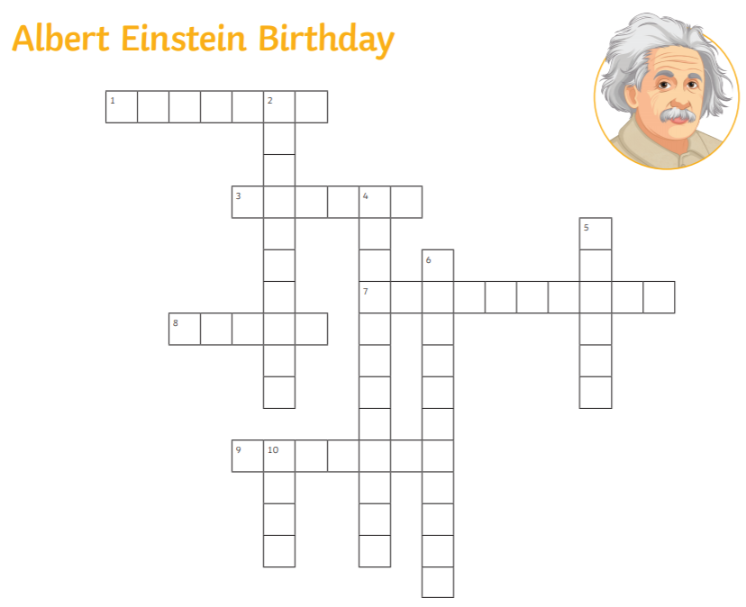

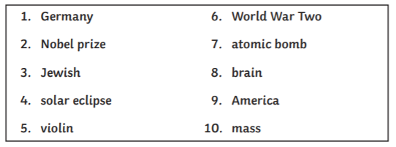

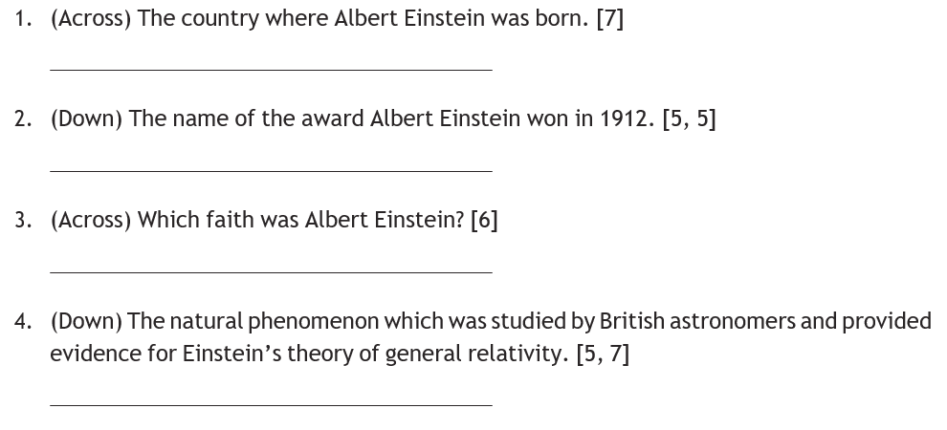

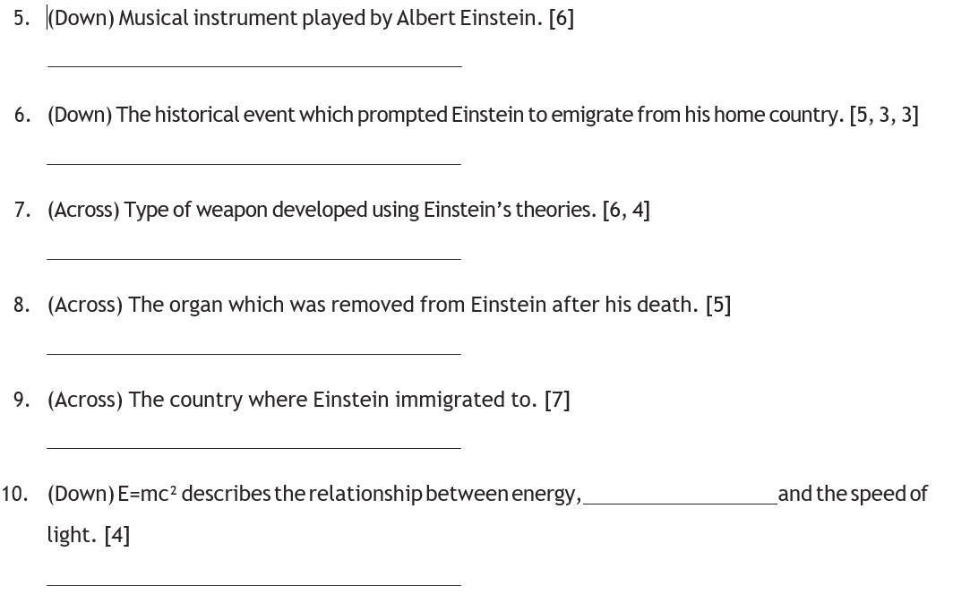

Use this template to create a crossword.
For example
– the answer could be ‘heart’
- The question could be ‘which organ pumps blood around the body’ [5 letters]

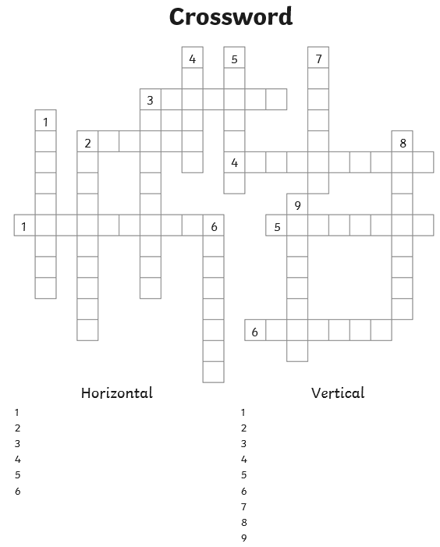

Challenge 2: Spellings

Learn the spellings and have a go at the test that goes with those key words

Test 1 | Test 2 | Test 3
1. heart | 1. cell | 1. roots
2. stomach | 2. nucleus | 2. leaves
3. skin | 3. cell membrane | 3. stems
4. brain | 4. mitochondria | 4. stamen
5. lung | 5. ribosome | 5. stigma
6. intestine | 6. cytoplasm | 6. petal

Test 4 | Test 5 | Test 6
1. lipid | 1. skeletal | 1. red blood cell
2. carbohydrate | 2. muscular | 2. nerve cell
3. fibre | 3. respiratory | 3. muscle cell
4. vitamins | 4. digestive | 4. sperm cell
5. minerals | 5. circulatory | 5. root hair cell
6. protein | 6. reproductive | 6. palisade cell  twinkl.com

Spelling Test 1

- The __________ pumps blood around the body.

- The _____________ holds and digests food.

- The human body is covered with ______.

- Our thoughts are controlled by our ________.

- The ________ is the site of gas exchange.

- The organ that absorbs nutrients from food is called the _______________.

Spelling Test 2

- The human body is made up of lots of ______.

- A controls the activities of a cell.

- Each cell is surrounded by a ____ ____________, it controls what enters and leaves a cell.

- Respiration occurs and releases energy in the __________________.

- Proteins are made by the ____________.

- In the ____________ chemical reactions occur.

Spelling Test 3
- In a plant the _________ take up water form the soil.

- A plant needs light to produce food, the _________ absorb the light.

- The ________ transports water and sugar throughout the plant.

- The _________ is the male reproductive organ of a plant.

- The _________ is the female reproductive organ of a plant.

- To attract an insect to the plant they have bright __________.
Spelling Test 4

- __________ are also known as fats, can be found in foods such as chocolate.

- Bread contains _____________, its provides energy to the body.

- _______ helps food pass through the digestive system.

- __________ can be found in fruit and vegetables.

- ___________ can be found in fruit and vegetables.

- ___________ helps repair muscle and can be found in meat.

Spelling Test 5

- A body must have a ___________ system in order to stand.

- For a body to move it must have a _____________ system.

- Air is taken in to the body and removed from the body through the _______________ system.

- Food is broken down and nutrients are absorbed by the _____________ system.

- Blood, oxygen and nutrients are pumped round the body through the ___________ system .

- The __________ system allows an organism to reproduce.

Spelling Test 6

- Oxygen is carried around the body by a _____ __________ ______.

- A ________ _____ will carry an electrical signal around the body.

- ________ _____ are held together in bundles.

- To fertilise an egg the ________ _____ will swim towards it.

- A plant absorbs water from the soil through the _________ ________ _____.

- Plants carry out photosynthesis, the ______________ _______ carries out that process.
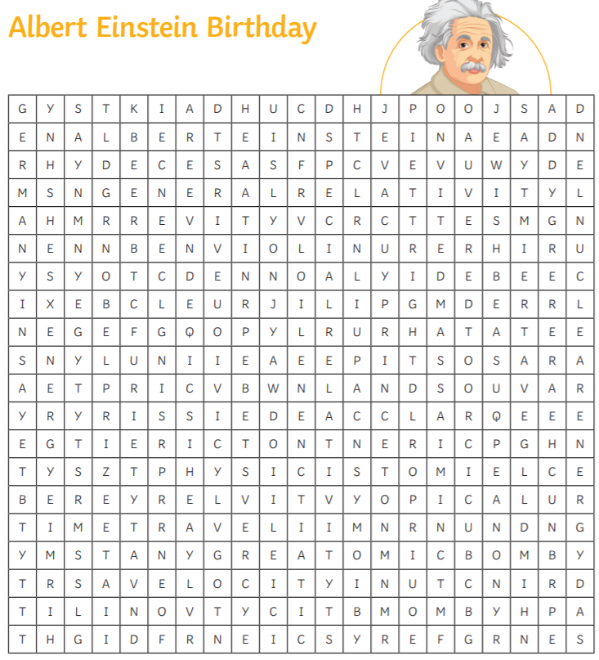
Challenge 3: Complete the wordsearch and create a wordsearch on forces

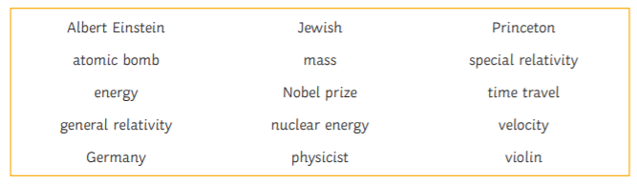

Write your word list here:

Challenge 4: Label the diagram of the flower.
Use these words to help:
Stigma, style, anther, ovary, petal, pollen tube, filament, ovule, stem
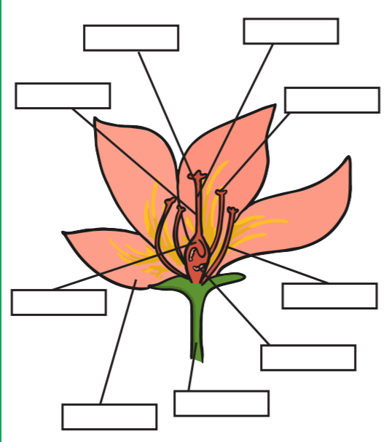

Answers
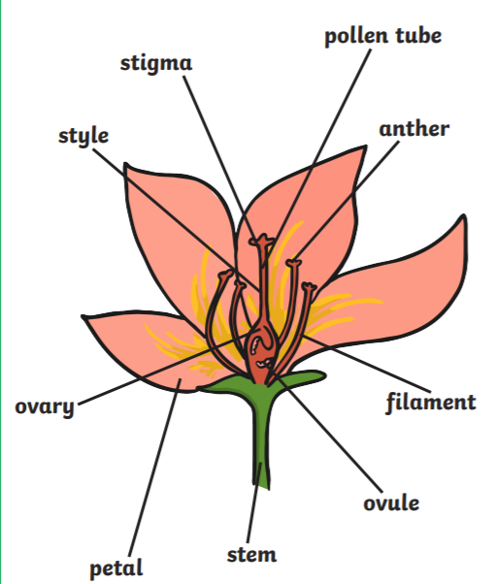
Challenge 5: Make a solar system mobile

3

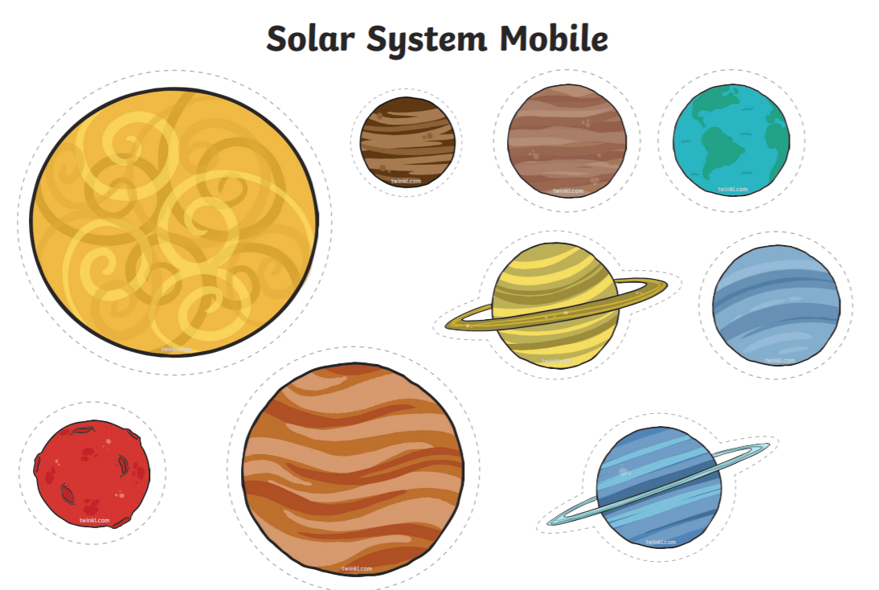
4 6

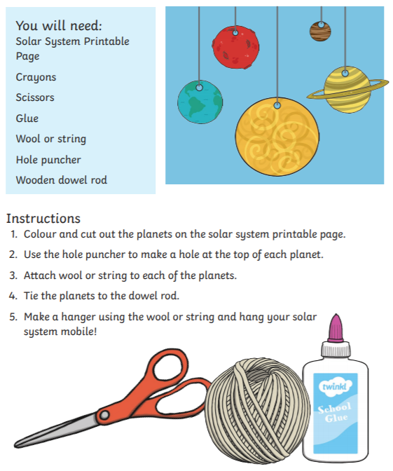

Challenge 6: Break the code, find the atomic number on the periodic table and write down the symbol!

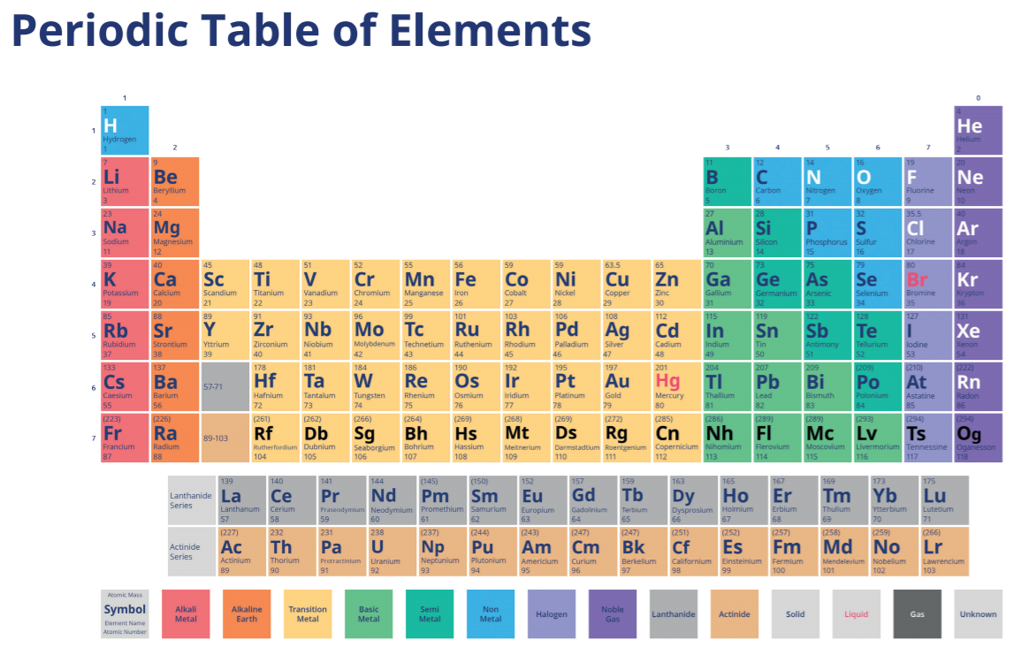
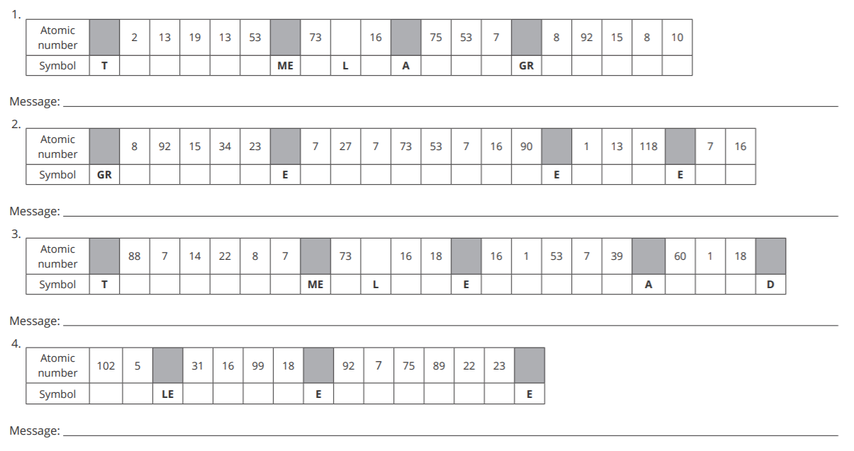
Extra challenge: Create your own secret messages using the periodic table
- Code:
Message:

- Code
Message:

- Code:
Message:

- Code:
Message:

- Code:
Message:

Challenge 7: Growing a rainbow experiment
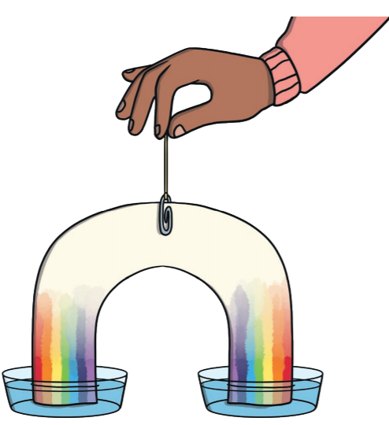
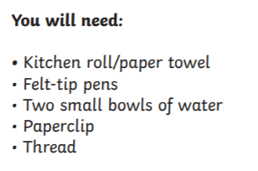

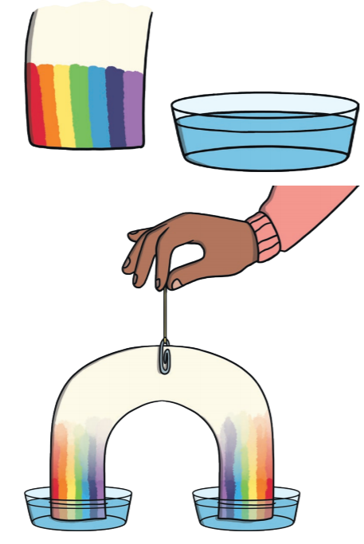
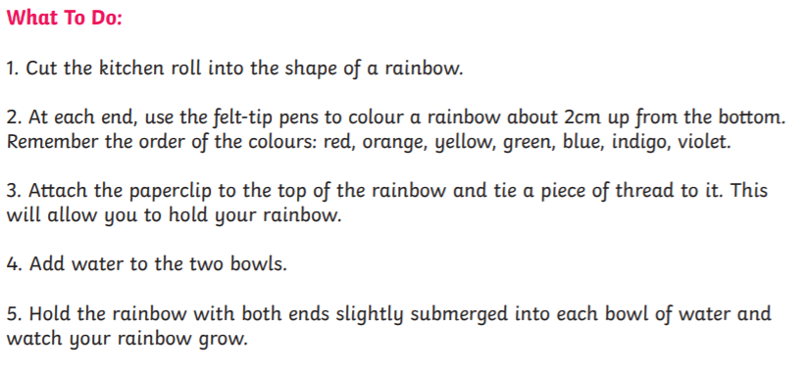

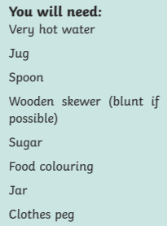
Challenge 8: Create your own sugar sparklers!
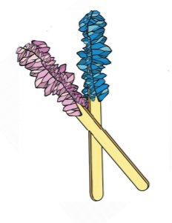
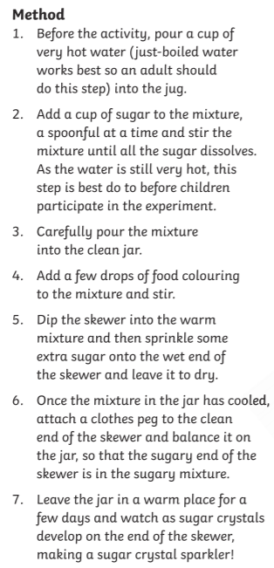

Please complete with an adult!!
Challenge 9: Complete the food chain below. Add the correct labels to the images.

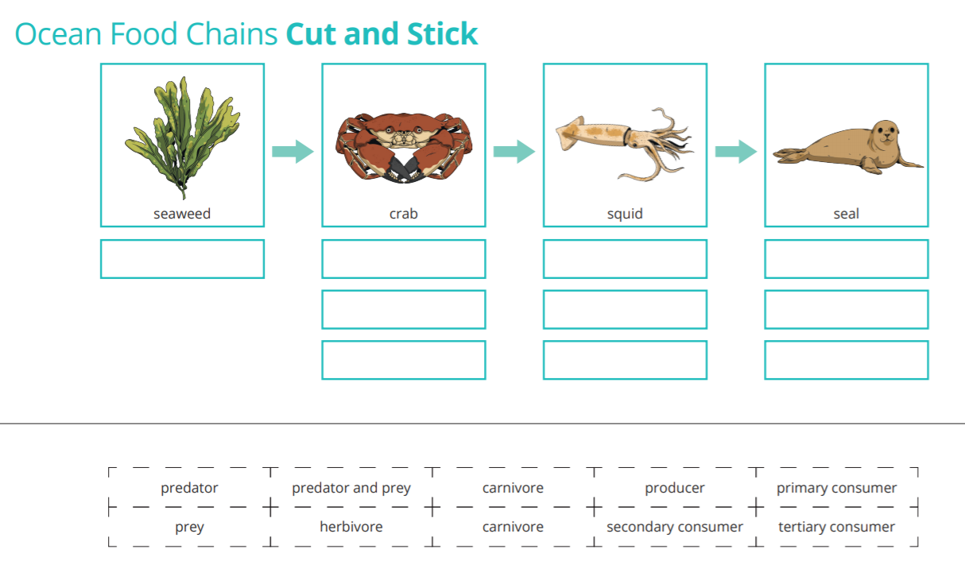

My very own food chain

Challenge 10: Cut and stick the correct parts of the respiratory system on the diagram. The labels are on the next page.
Then stick the correct function next to the correct part.
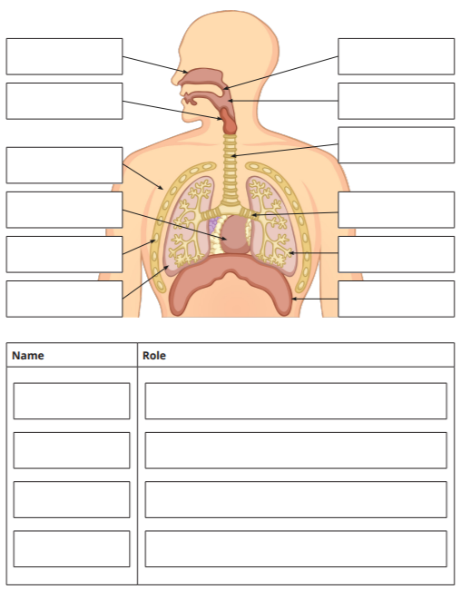
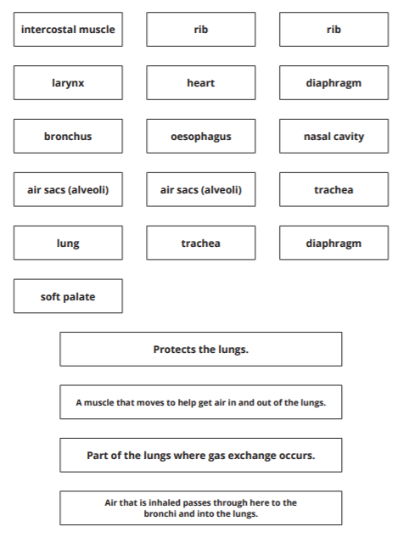

Answers
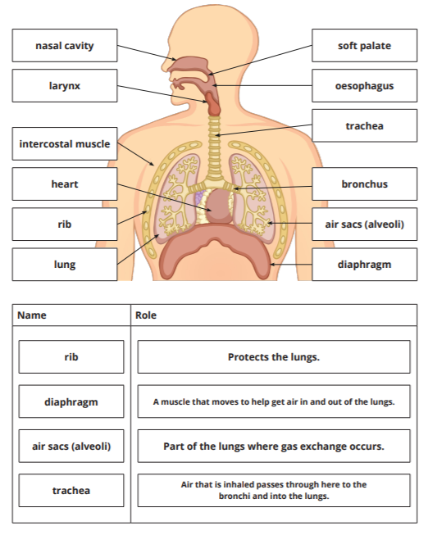

Challenge 11: Complete the revision mats on biology, chemistry and physics

The answers for each placemat are on the following page.

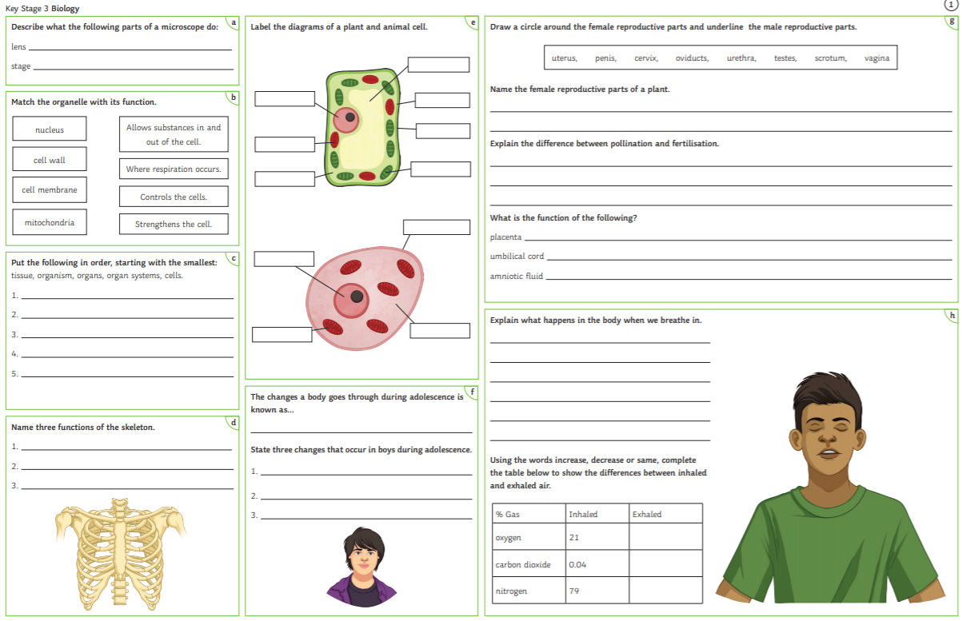

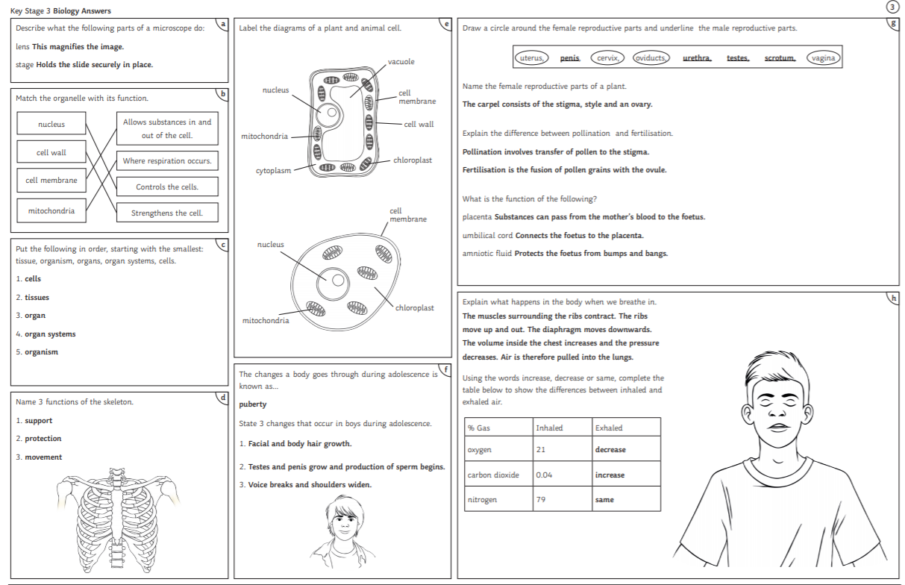
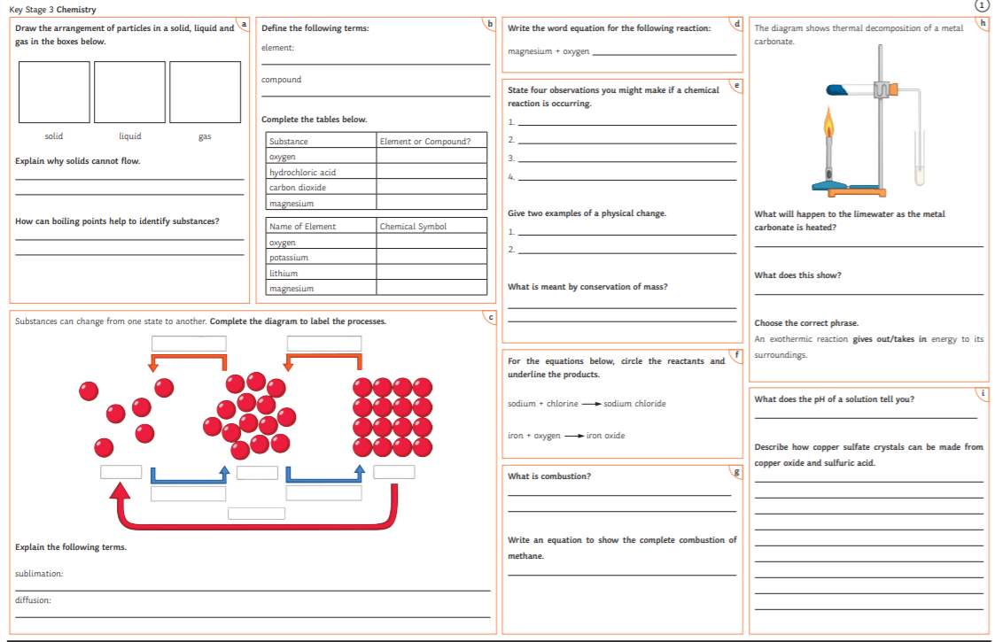
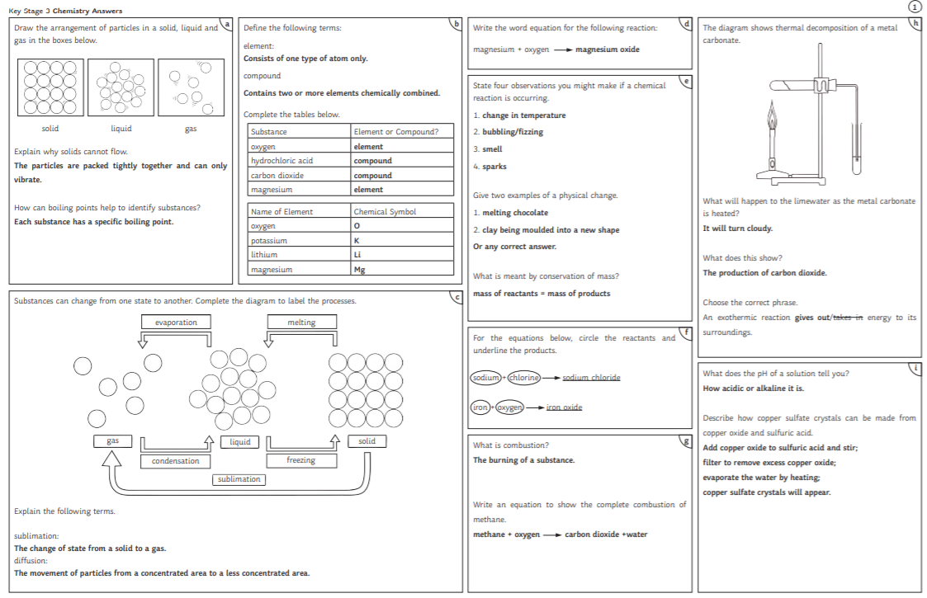

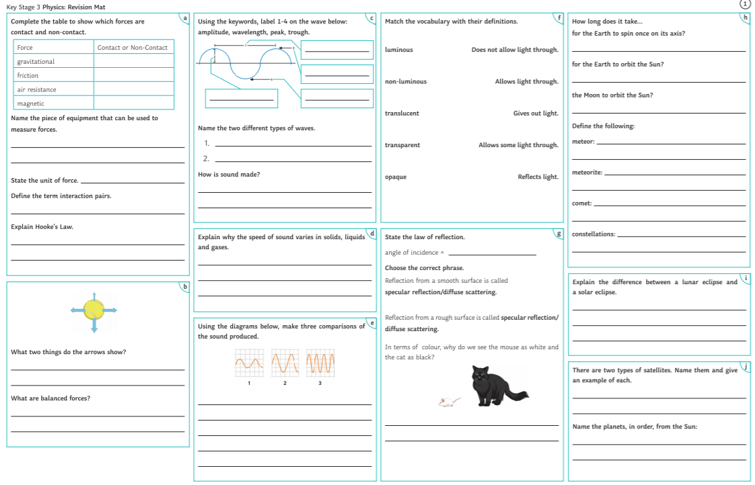
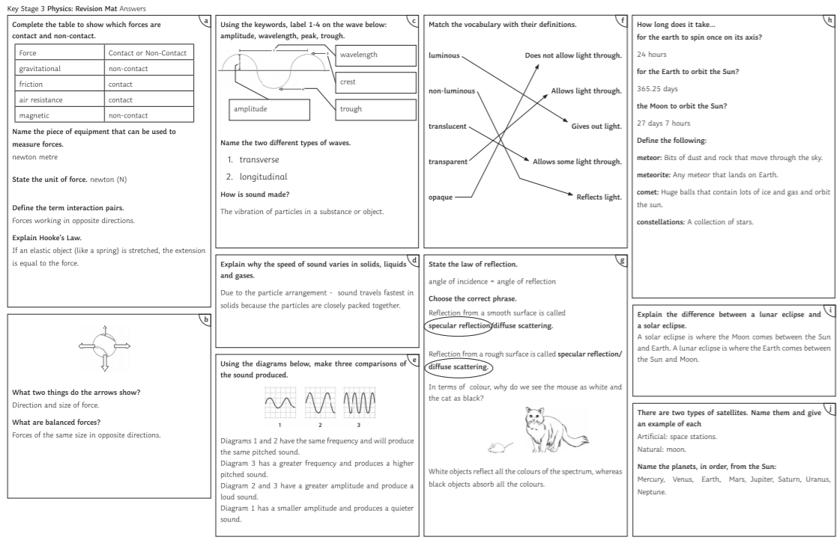

Challenge 12: Make your own erupting volcano! Here are a list of thigs you will need! Take a video if your volcano and send it in!
Making Your Volcano
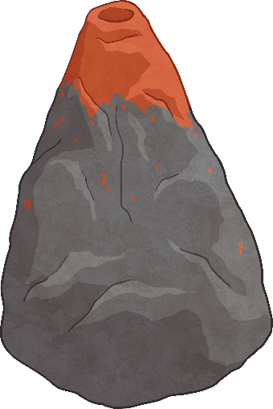
Method
- Fold your newspaper up to make several strips, about
1 inch thick.

- Working from the bottom up, apply glue to your bottle, then wrap the newspaper strips around it.

- Build up the layers to create a volcano shape – you’ll need to add more strips to the bottom to make it wider.

- Remember: do not cover the hole at the top of the bottle.

- When you are happy with the shape, add torn pieces of newspaper over the top to smooth out the layers.

- Allow the glue to dry completely for at least 24 hours.

- Paint your volcano to give it a realistic look

Making Your Volcano
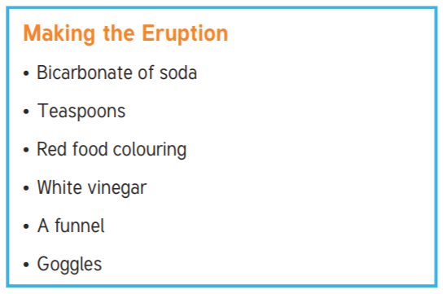
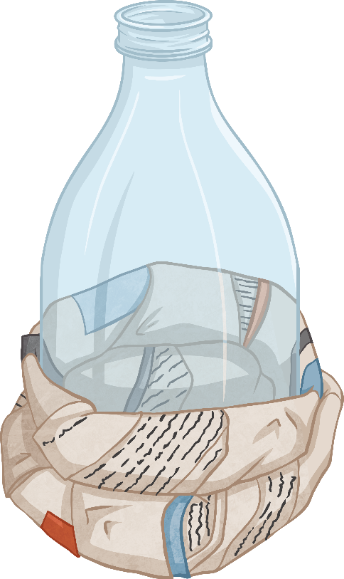

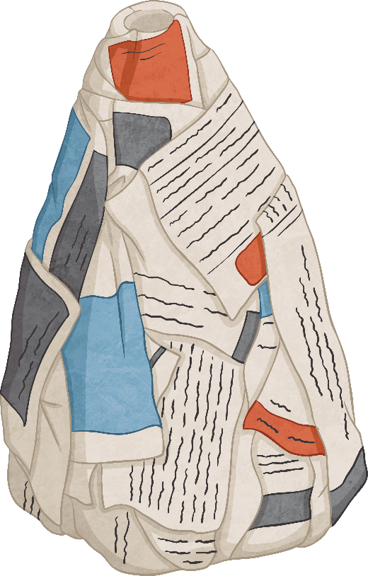
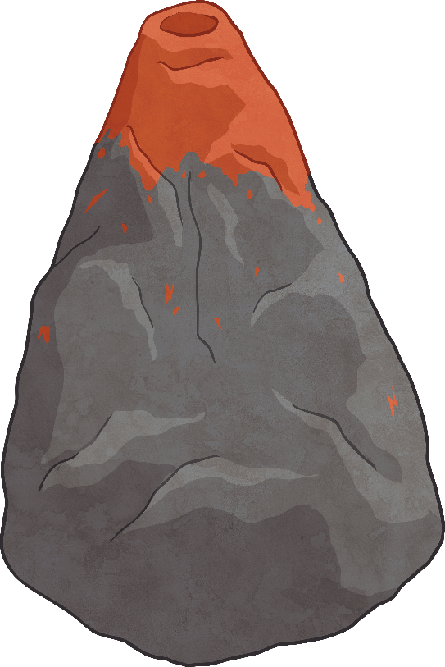
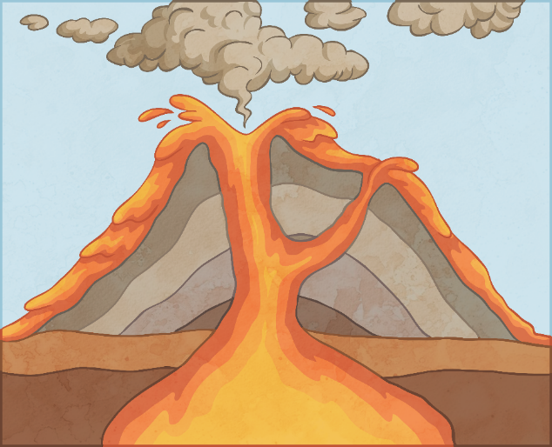
Make a video of your volcanic eruption and send it in to your teacher!!!
Method
- Put your goggles on

- Place the funnel in the top of your bottle

- Add 4 teaspoons of bicarbonate of soda to the bottle

- Pour a generous amount of white vinegar into a beaker and add a small amount of red food dye

- Quickly pour the vinegar into the bottle and watch the volcano erupt
Volcano Eruption

